Chapter 12, Solution 26.

Using Fig. 12.55, design a problem to help other students to better understand balanced delta connected sources delivering power to balanced wye connected loads.

Although there are many ways to solve this problem, this is an example based on the same kind of problem asked in the third edition.

Problem

For the balanced circuit in Fig. 12.55, V_{ab} = 125∠0° V. Find the line currents I_{aA}, I_{bB}, and I_{cC}.

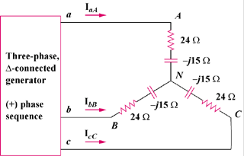

Figure 12.55

Solution

Transform the source to its wye equivalent.
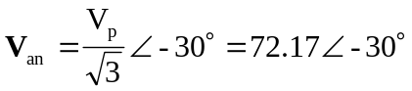

Now, use the per-phase equivalent circuit.
 